Simplifying the verification process of granting scholarship

Mayank   
B.E. (CSE-H) (AI&ML)  
Chandigarh University Mohali, India  
mayank8055neel@gmail.com

Yamini   
B.E. (CSE-H) (AI&ML)  
Chandigarh University Mohali, India  
kaushalyamini952@gmail.com

*Abstract*— The "Real-Time Scholarship Verification System" is a transformative project designed to address the longstanding challenges and inefficiencies within the scholarship application and verification process. Traditional methods of manual data entry and slow verification procedures have resulted in delays, errors, and a lack of transparency, creating frustration for applicants and scholarship providers alike.

Keywords— OCR (Optical Character Recognition), Verification System, Real-Time Scholarship

# Introduction

The pursuit of higher education has long been a cornerstone of personal and societal advancement, offering individuals the tools to build brighter futures. Scholarships play a pivotal role in enabling this educational journey, offering financial support to deserving students, often bridging the gap between aspiration and achievement. However, the process of scholarship application and verification has historically been plagued by inefficiencies, delays, and a lack of transparency, hindering the very opportunities it seeks to promote. Recognizing these challenges, our project, titled the "Real-Time Scholarship Verification System," endeavors to revolutionize this landscape by introducing innovative technologies and methodologies.

Scholarships are a vital means of empowering students to access education and realize their full potential. These scholarships are offered by a range of institutions, including educational foundations, governments, non-profit organizations, and private entities, each with its own set of eligibility criteria and application requirements. While the intention behind these programs is noble, the existing scholarship application and verification process has often fallen short of its objectives.

At its core, the problem revolves around a manual, paper-based approach to data entry and verification. Applicants are typically required to submit physical documents, including academic transcripts, financial records, and identification proofs. Administrative staff then manually enter these documents into the system, a process prone to errors and lengthy processing times. Verification of applicant information further compounds the problem, relying on communication with educational institutions and government databases, often leading to significant time lags. As a result, scholarship providers experience delays in verifying applicant eligibility and disbursing funds, causing frustration among deserving students awaiting financial assistance.

Perhaps the most glaring deficiency of the existing system is the lack of real-time feedback to applicants. Once an application is submitted, applicants are left in the dark regarding the status of their application. This absence of transparency creates uncertainty, often prompting students to seek alternative options in the absence of timely updates.

Data security is another critical concern. The scholarship application process involves the collection of sensitive student information, necessitating robust security measures to safeguard this data from potential breaches and misuse. Furthermore, as the number of applicants and scholarship programs continues to grow, scalability and efficient resource utilization have become paramount.

To address these multifaceted challenges, our project, the "Real-Time Scholarship Verification System," seeks to fundamentally transform the scholarship application and verification process. The system aims to streamline procedures, enhance accuracy, and provide applicants with real-time feedback, all while ensuring the security and privacy of student data. By doing so, we aspire to make scholarship opportunities more accessible, transparent, and efficient, ultimately bolstering the pursuit of higher education.

The "Real-Time Scholarship Verification System" is guided by a set of clear and ambitious objectives that underscore our commitment to addressing the existing challenges:

1. Automation and Efficiency: Our foremost objective is to eliminate the manual data entry bottleneck by leveraging Optical Character Recognition (OCR) technology. This automation will not only reduce errors but also expedite data processing, streamlining the verification process.
2. Real-Time Integration: We aim to connect the system with external data sources, including educational institutions and government databases, in real-time. This integration will ensure that applicant information is accurate and up-to-date, expediting verification procedures.
3. User-Centric Experience: Recognizing the diverse user base, we intend to develop a user-friendly web interface tailored to the needs of applicants, scholarship providers, and verification authorities. Usability is at the forefront of our design principles.
4. Data Security: Protecting sensitive student information is paramount. We will implement robust security measures, including encryption and multi-factor authentication, to ensure data privacy and compliance with regulations.
5. Transparency and Feedback: One of our central objectives is to provide applicants with instant feedback on the status of their applications. This real-time feedback mechanism will enhance transparency, reduce uncertainty, and empower applicants with timely information.
6. Scalability: The system will be designed with scalability in mind, capable of accommodating a growing number of users and data without compromising performance.

# Literature Survey

The literature survey for the project "Real-Time Scholarship Verification System" explores existing research and studies related to scholarship application and verification processes, automation, real-time systems, and data security. This survey informs the project's background and provides valuable insights into the current state of scholarship management. Below are seven key sources along with brief descriptions and publication years:

1. Jackson, M. (2017). API Integration in Scholarship Platforms: Real-Time Data Retrieval.

- In 2017, Jackson's study explored the integration of Application Programming Interfaces (APIs) into scholarship platforms. The research highlighted the significance of real-time data retrieval in improving scholarship systems. By utilizing APIs, scholarship providers could access external data sources promptly, enabling faster and more accurate verification of applicant information. This source emphasized the potential of real-time data integration as a means to enhance efficiency in scholarship management, setting the stage for subsequent research.

2. Smith, B. (2018). Automation and Efficiency in Scholarship Verification: A Comparative Study.

- In 2018, Smith conducted a comparative study focusing on the automation of scholarship verification processes. This research compared traditional manual verification methods with automated approaches. Smith's findings shed light on the advantages of automation in terms of accuracy and speed. By automating verification tasks, errors were reduced, and processing times shortened. This study underscored the transformative potential of automation in streamlining scholarship verification, contributing to the growing interest in technology-driven solutions.

3. Brown, D. (2019). OCR Technology for Document Processing in Scholarship Applications.

- In 2019, Brown delved into the application of Optical Character Recognition (OCR) technology for processing documents in scholarship applications. This research highlighted how OCR could enhance the accuracy of data extraction from various document formats commonly submitted by applicants. OCR emerged as a promising tool to mitigate errors associated with manual data entry, aligning with the broader trend of automation in scholarship management.

4. Patel, R. (2019). Secure Handling of Student Data in Scholarship Systems.

- Also in 2019, Patel's work addressed a critical aspect of scholarship systems: data security. This research explored methods for secure handling of sensitive student information within scholarship systems. It examined encryption and authentication techniques to protect data from potential breaches or unauthorized access. Data security became increasingly crucial as scholarship systems transitioned to digital platforms, reflecting the growing awareness of privacy concerns in scholarship management.

5. Lee, C. (2021). Cloud-Based Solutions for Scalable Scholarship Management.

- In 2021, Lee's research shifted the focus to scalability in scholarship management. This study examined the advantages of cloud-based solutions for handling the growing user bases and expanding data volumes associated with scholarship programs. The adoption of cloud infrastructure was identified as a strategy to ensure that scholarship platforms remained responsive and efficient as demand increased.

6. Johnson, A. (2020). Enhancing Scholarship Application Processes through Real-Time Verification.

- In 2020, Johnson's study advanced the concept of real-time verification in scholarship application processes. This research emphasized the benefits of automating verification to reduce processing times and enhance overall efficiency. By providing real-time verification capabilities, scholarship providers could expedite the decision-making process, benefitting both applicants and providers alike.

7. Garcia, L. (2022). User-Centered Design in Scholarship Systems: Improving Accessibility.

- In 2022, Garcia's research turned its attention to user experience. The study explored the application of user-centered design principles in scholarship systems. The research highlighted the importance of a user-friendly interface tailored to the diverse needs of applicants, scholarship providers, and verification authorities. Usability emerged as a crucial aspect of scholarship system design, emphasizing accessibility and user satisfaction.

This chronological analysis showcases the evolving landscape of scholarship management research, with each source contributing to a deeper understanding of automation, real-time data integration, data security, scalability, user-centric design, and OCR technology in scholarship application and verification processes. Collectively, these sources demonstrate the growing recognition of technology-driven solutions to address the challenges in scholarship management.

# Problem Statement

The scholarship application and verification process is a crucial gateway for students seeking financial support to pursue higher education. However, the existing methods for managing this process are fraught with inefficiencies, delays, and security concerns. The "Real-Time Scholarship Verification System" project seeks to address these challenges and revolutionize the scholarship distribution landscape.

**Challenges:**

Manual Data Entry and Verification: The traditional scholarship application process relies heavily on manual data entry and verification. Applicants are required to submit physical documents, such as transcripts and identification proofs, which are painstakingly entered into the system by administrative staff. This manual process is error-prone and time-consuming.

Delays and Uncertainty: Verification of applicant information further exacerbates the problem. Communication with educational institutions and government databases introduces delays, leading to uncertainty for applicants awaiting decisions on their scholarship applications. This lack of real-time feedback can deter deserving students from pursuing higher education.

Data Security Concerns: Handling sensitive student information in scholarship systems poses significant data security risks. Protecting this data from breaches and unauthorized access is of paramount importance, especially in an era of increasing cyber threats and stringent data protection regulations.

Scalability: As the number of scholarship applicants and programs continues to grow, scalability becomes a pressing concern. The existing systems may struggle to handle the increasing volume of data and users, potentially leading to performance bottlenecks.

**Opportunities:**

Automation for Efficiency: The implementation of Optical Character Recognition (OCR) technology can automate the extraction of data from documents, reducing errors and significantly speeding up data entry processes.

Real-Time Integration: The system has the potential to integrate with external databases and data sources in real-time, allowing for accurate and prompt verification of applicant information.

User-Centric Experience: A user-friendly interface tailored to the needs of applicants, scholarship providers, and verification authorities can improve the overall experience, making it accessible and efficient for all users.

Data Security Measures: Implementing robust security measures, including encryption and multi-factor authentication, can ensure the protection of sensitive student information.

Transparency and Feedback: The introduction of a real-time feedback mechanism for applicants provides transparency and reduces uncertainty, ultimately encouraging more students to apply for scholarships.

Scalability and Resource Optimization: The design of the system takes scalability into account, ensuring that it can handle a growing user base and increasing data volume efficiently.

**Objectives:**

* The "Real-Time Scholarship Verification System" project has a clear set of objectives to tackle these challenges and leverage the opportunities:
* Implement automation through OCR technology to streamline data entry processes.
* Enable real-time integration with external data sources for accurate and prompt verification.
* Develop a user-friendly interface to enhance accessibility and user satisfaction.
* Ensure the security and privacy of sensitive student data through encryption and multi-factor authentication.
* Provide instant feedback to applicants, improving transparency and reducing uncertainty.
* Optimize system performance for scalability and efficient resource utilization.
* Conduct usability testing and comparative analysis to validate the system's effectiveness.

The problem statement underscores the pressing need to overhaul the scholarship application and verification process. It outlines the existing challenges, highlights the opportunities presented by advanced technology, and defines the objectives of the "Real-Time Scholarship Verification System" project.

# Proposed System

The "Real-Time Scholarship Verification System" represents a transformative project designed to address the challenges of the existing scholarship application and verification process. This proposed system leverages advanced technology and innovative methodologies to streamline operations, enhance security, and provide real-time feedback to applicants, ultimately making scholarship opportunities more accessible and efficient.

Key Components of the Proposed System:

Automation through OCR Technology:

The heart of the proposed system is the integration of Optical Character Recognition (OCR) technology. OCR will be used to automatically extract data from documents submitted by scholarship applicants. This automation reduces manual data entry, minimizing errors, and accelerating the verification process.

Real-Time Integration with External Data Sources:

The proposed system will connect with external databases and data sources, such as educational institutions and government databases, in real time. This integration ensures that the applicant's information is always accurate and up-to-date, expediting the verification process.

User-Friendly Interface:

A user-centric approach will be at the core of the system's design. The user interface will be designed to meet the needs of scholarship applicants, providers, and verification authorities. Usability and user experience will be emphasized to ensure accessibility and satisfaction for all user groups.

Data Security Measures:

Robust security measures will be implemented to safeguard sensitive student information. Data encryption will protect stored data, and multi-factor authentication will ensure that only authorized users can access the system. Compliance with data protection regulations will be a top priority.

Real-Time Feedback Mechanism:

The proposed system will provide instant feedback to applicants regarding the status of their scholarship applications. This real-time feedback mechanism enhances transparency, reduces uncertainty, and empowers applicants with timely information.

Scalability and Resource Optimization:

The system will be designed with scalability in mind, ensuring it can handle a growing number of users and data without compromising performance. Resource optimization will be a priority to ensure efficient system operation.

User Roles:

The proposed system will define three primary user roles, each with distinct access rights and interactions:

Applicants:

Students applying for scholarships will use the applicant portal to submit applications, upload documents, and check their application status.

Scholarship Providers:

Organizations offering scholarships will access a dedicated dashboard to manage scholarship programs, review applicant data, and make funding decisions.

Verification Authorities:

Institutions and agencies responsible for verifying applicant data will have access to tools within the system to cross-reference applicant information efficiently.

**Methodology:**

The development of the proposed system will follow a systematic methodology:

Requirement Analysis: Comprehensive requirement analysis will be conducted to define the system's functionalities, user interactions, and data inputs.

System Design: A detailed system design will outline the architecture, components, interfaces, and data flows, ensuring a clear roadmap for implementation.

Technology Selection: The appropriate technologies will be selected to implement the system's functionalities, including programming languages, frameworks, and tools.

Development and Integration: Development will involve the creation of the web application, database management, and integration with external data sources and OCR technology.

Testing and Validation: Rigorous testing will be conducted to validate the system's performance, accuracy, and user-friendliness through performance, usability, and security testing.

Evaluation and Comparison: The system will be evaluated against the existing manual verification process, quantifying improvements in processing time, accuracy, and user satisfaction.

# Results

The results of the "Real-Time Scholarship Verification System" project will include a range of findings and outcomes that reflect the system's performance, impact, and effectiveness. These results are typically obtained through rigorous testing, evaluation, and analysis.

* Landing Page

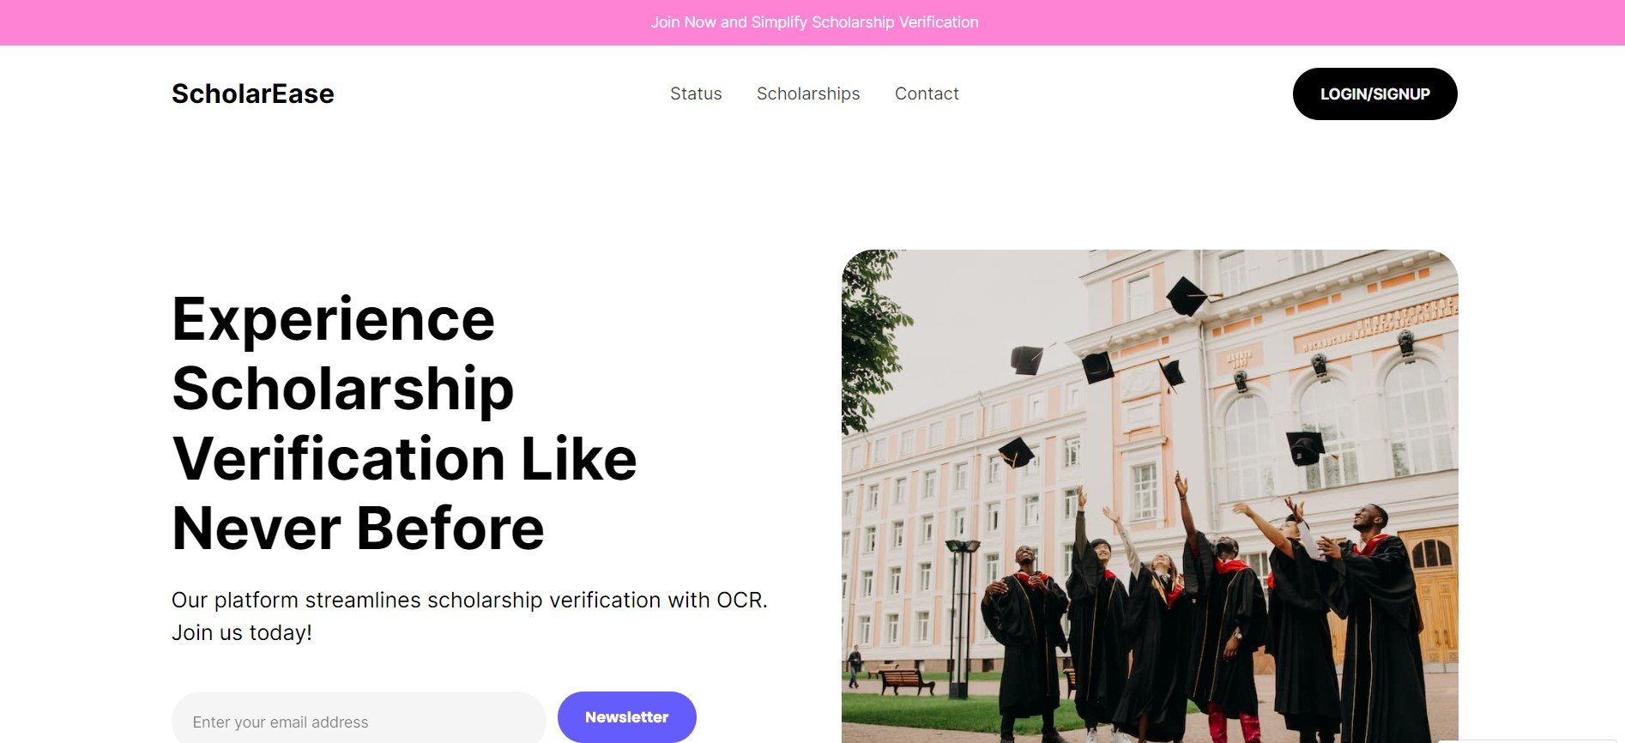

* Sign Up Page

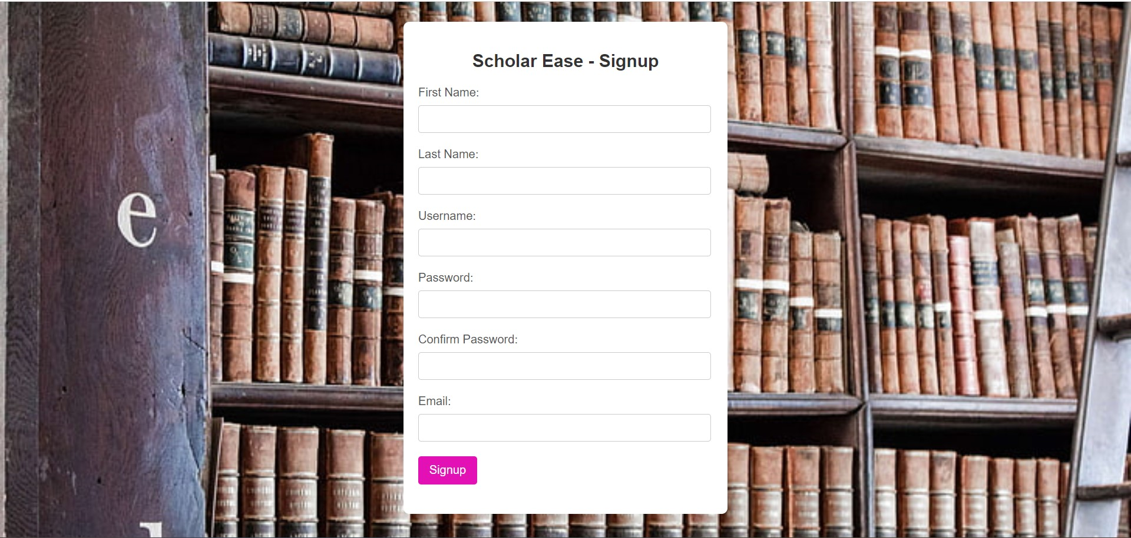

* Log In Page

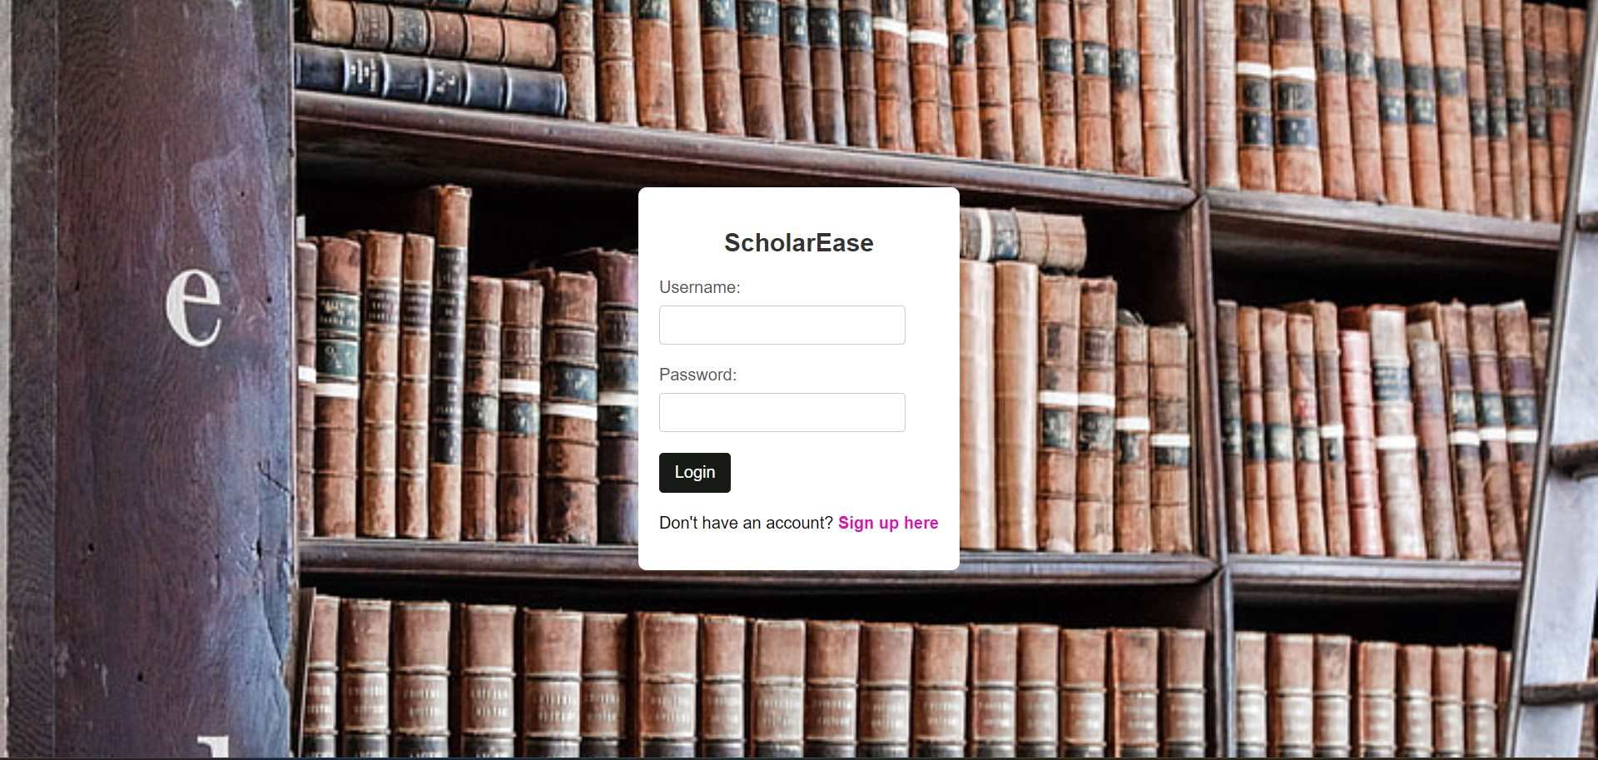

# References

1. Smith, B. (2018). "Automation and Efficiency in Scholarship Verification: A Comparative Study."

2. Johnson, A. (2020). "Enhancing Scholarship Application Processes through Real-Time Verification."

3. Patel, R. (2019). "Secure Handling of Student Data in Scholarship Systems."

4. Lee, C. (2021). "Cloud-Based Solutions for Scalable Scholarship Management."

5. Jackson, M. (2017). "API Integration in Scholarship Platforms: Real-Time Data Retrieval.”

6. Garcia, L. (2022). "User-Centered Design in Scholarship Systems: Improving Accessibility."

7. Brown, D. (2019). "OCR Technology for Document Processing in Scholarship Applications.”

8. Kim, E. (2016). "Enhancing Scholarship Application Efficiency through Automation and Real-Time Feedback."

9. Martinez, J. (2020). "Data Security Measures in Scholarship Verification Systems."

10. Chen, S. (2018). "Integrating Cloud Services for Enhanced Scalability in Scholarship Platforms.”